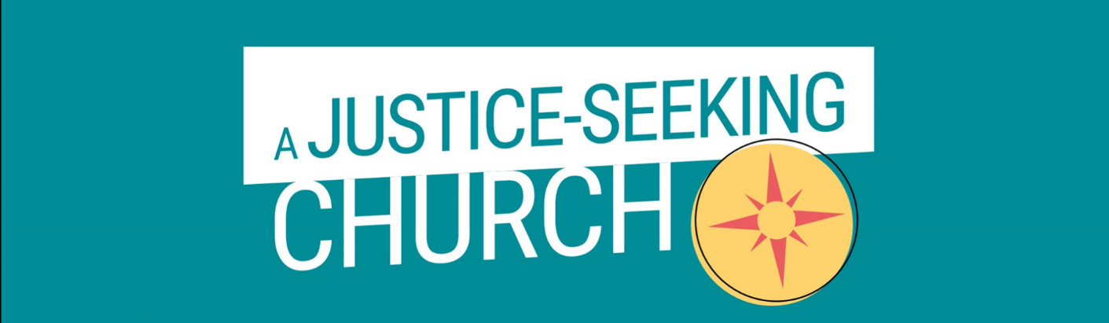
Church for Change!
Exploring 300 years of Methodist Social Justice
The Salisbury Circuit Justice and Peace Group hosts a screening of “the best bits” from this superb conference that took place at The Oxford Centre for Methodism and Church History in November.

Highlights include:
Prof. Pippa Catterall on changing the public imagination of what is possible and how to build a better society
Dr Munyurangabo R. Benda on genocide, forgiveness and the future
Dr Clive Norris on developing a practical theology of resistance and ethical action
John Cooper on working for peace and non-violent living
Rev’d Dr Jill Marsh on simplicity and inclusion
Rev’d Mark Rowland and Prof Bev Clack on building a transformational community of diverse people who can disagree positively

Join us to watch video highlights and share refreshments and conversation at
Woodfalls Methodist Church
Saturday 3rd February 2024
10am-2pm
